SOCIAL STATISTICS
SOC 24100
Homework #9
Due: May 7

Questions
- What types of variables (nominal, ordinal, or interval-ratio) can we use to create a scatterplot?

A Scatter plot is used for displaying and examining a relationship between two variables, on ordinal, interval-ratio, one continuous variable that is under the control of the experiment and the other depends on it or when both are continuous variables are independent.

- Which variable goes along the X axis of a graph (independent or dependent)? Which goes along the Y axis?

Independent variable on the horizontal axis and the dependent variable on the vertical axis.

- What is a least-squares line?

Is the line that makes the vertical distance from the data points to the regression line as small as possible. The best line of fit minimizes the variance.

- Given the regression equation Y=20,000 + 250X, do the following:
  - Identify and interpret a

a is the slope =250.Indicates the rate of change in y per unit change in x,An increase in x by one unit, the value of y increases by 250
  - Identify and interpret b

b=20,00indicates the y-value when x-value is zero (0), the point where the line crosses the y-axis
- If the r² value of the relationship between age and income was 0.41, how would you interpret that?
This indicates that 41% of the variance in the dependent (income) that the independent variable (age) explains collectively.
It reveals that 41% of the data fit the regression model.
- How would we interpret an r of -0.23?
The sampled individuals are scattered around the e variables. Since 0.23 is small the all-individuals samples lie exactly on the less well the data can be visualized by a single linear relationship.

- The graph below shows the relationship between fertility rate and life expectancy—every circle represents one country, with the size of the circles representing the population size of the country and the colors representing region of the world.
  - Describe the relationship between fertility rate and life expectancy.

The scatter graph indicates a small negative correlation between fertility rate and life expectancy. As fertility rate increases, the life expectancy decreases. There is an inverse relationship between the variables.

  - Choose one region of the world and make observations about their fertility rate and life expectancy in comparison to the other regions.

East Asia has a high life expectancy compared to South Asia and Sub-Saharan Africa.

East Asia and Pacific. The scatter plot indicates a strong negative relationship between fertility rate and life expectancy. A decrease in fertility rate leads to an increase in life expectancy.

The graph clearly shows that East Asia has lower mortality rate compared to Sub-Saharan, Middle East and North Africa.
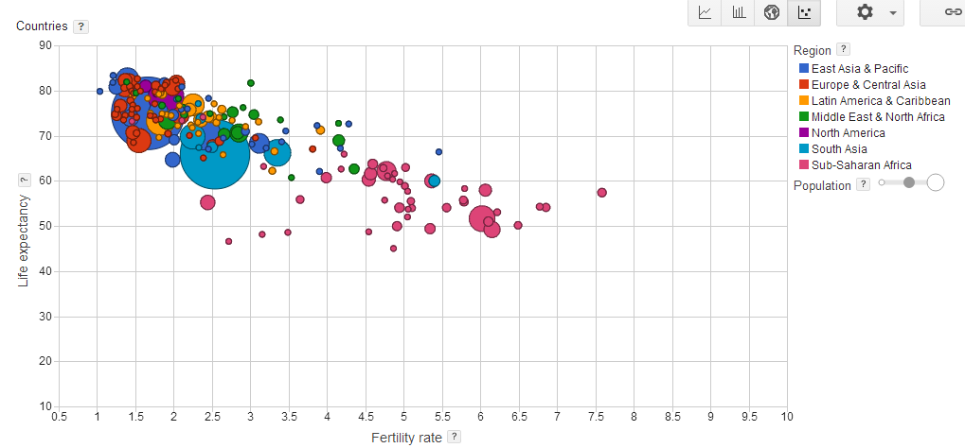

Source: https://www.google.com/publicdata/directory

